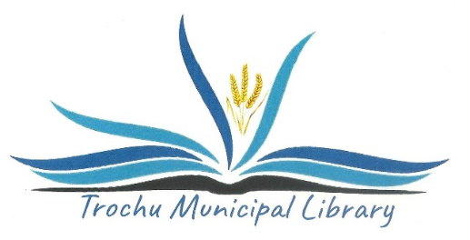
TROCHU MUNICIPAL LIBRARY BOARD
RECORDS MANAGEMENT POLICY

- The storage of files held by the Trochu Municipal Library is to be kept to the legal minimum consistent with the efficient operation of the organization and the preservation of a meaningful historical record of the library.

- When records are deemed to be vital, the confidentiality or security of the file and the implications of their possible loss or destruction should be taken into account.

- The costs for space, storage, and handling of files should be kept to a minimum.

- The Library Manager will maintain adequate records to compile monthly and annual activity reports.

- The Trochu Municipal Library Board shall keep orderly and timely record of its business so that its records are compliant with Federal rules and regulations. The Income Tax Act of Canada is cited as the authority for the retention of financial records.

- Once the official minutes have been accepted, all notes and drafts relating to the meetings may be destroyed. The minutes of Library Board meetings are deemed to be the historical records of the library and must be kept permanently.

- With the exception of patron records and personnel records, the records of the Library are deemed to be public information.

- All patron records are confidential unless subpoenaed by law.

- The Board has authority for the destruction of records.

See: Appendix A: Record retention community libraries PDF.
Appendix B: Record retention Marigold Board PDF.

Reviewed April 2019
Approved by the board June 11, 2019
Reviewed and revised at the planning meeting March 4th 2020
Approved at the AGM May 5th 2020

--------------------------------------
Randy Lacey, Board Chairperson

